Chapter 17, Solution 61.

(a) ω_{o} = 1.

f(t) = a_{o} + 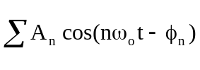
= 6 + 4cos(t + 50°) + 2cos(2t + 35°)
+ cos(3t + 25°) + 0.5cos(4t + 20°)

= 6 + 4cos(t)cos(50°) – 4sin(t)sin(50°) + 2cos(2t)cos(35°)
– 2sin(2t)sin(35°) + cos(3t)cos(25°) – sin(3t)sin(25°)
+ 0.5cos(4t)cos(20°) – 0.5sin(4t)sin(20°)

= 6 + 2.571cos(t) – 3.73sin(t) + 1.635cos(2t)
– 1.147sin(2t) + 0.906cos(3t) – 0.423sin(3t)
+ 0.47cos(4t) – 0.171sin(4t)

(b) f_{rms} = 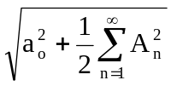

f_{rms}² = 6² + 0.5[4² + 2² + 1² + (0.5)²] = 46.625

f_{rms} = 6.828

